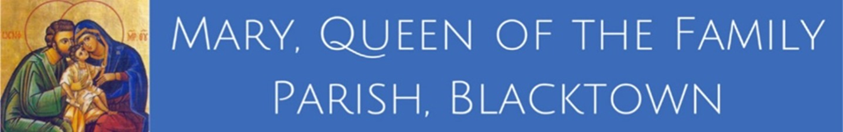

MARY, QUEEN OF THE FAMILY PARISH – PASTORAL COUNCIL MEETING
Board Meeting Room, St Patrick’s Church
21 May 2026, 7:00pm - Minutes

1. Opening Prayer
The meeting commenced with prayer. Members in attendance.
2. Reflection
Daniel Mangabat reflected on 1 Corinthians 12, highlighting the importance of Spiritual Gifts in preparation for Pentecost Sunday.
3. Attendance and Apologies
Present: Vince Tabone, Daniel Mangabat, Helena Vea, Fran Satchell, Don DeMello, Trevor Brewty, Fr Wim Hoekstra, Fr Stephen Onyekwere, Deacon John Cinya.
Apologies: Eva Cheetley, Erica Luiz, Savita Surrendra, Josh Carr, Marian Asiegbu, Cryste Degallacion, Fr Tom Green.
4. Minutes of the Previous Meeting
The minutes of the meeting held 16 April 2026 were accepted as a true and accurate record. Moved: Don DeMello. Seconded: Trevor Brewty. Motion CARRIED.
5. Business Arising (Not on the Agenda)
5.1 – Pilot Program: WhatsApp Community Groups
Don DeMello and Trevor Brewty outlined the purpose and structure of the Parish WhatsApp Community Groups. The three-month pilot continues, with two months remaining.
Proposed sub-communities include:
- St Joseph’s Men’s Group
- Victus Youth Ministry
- Events
- PPC Executive Team
- Parish Pastoral Council
  - PPC Sub-Strategy Categorisation
Action: Don and Trevor to continue progressing the pilot and provide updates. Eva and Helena to assist with administration.
5.2 – Building Strong Marriages Conference
Fr Stephen shared positive feedback from the conference held 24 April 2026 at St Andrews Hall, Marayong.
5.3 – Blacktown Quarter / Parish Quarter Update
Fr Wim provided an update on the draft Phase 2 Governance Structure, including the development of the project business case and the call for Expressions of Interest (EOI) for subcommittees.
Action: PPC members to submit EOI forms within three weeks. More info will be included in the bulletin
5.4 – Alpha Report
Fran reported that Alpha is now in Week 6, with 30 participants. The Alpha Retreat will be held 23–24 May 2026. Participants will attend Pentecost Sunday Mass to receive a blessing from Fr Stephen.
6. Business
6.1 – Welcome Committee
Discussion focused on forming a Welcome Committee across Masses at both churches.
Actions:
- Helena to submit names for name badges to Jill and Sarah.
- Fran to draft a “Talented & Gifted” survey for parishioners; Fr Wim and Jill to finalise.
6.2 – Communications & Media
The council reviewed current communication channels:
- WhatsApp Community Groups
- Email communications
- Parish Bulletin
- Social Media (Facebook, Instagram)
- MQOF Website
Discussion highlighted the growing need for a Communications & Media Team to support Jill and ensure consistent weekly updates.
Action: Item to be revisited at the next meeting.
6.3 – Youth Update
No update available (Cryste and Fr Tom absent).
6.4 – Events
6.4.1 – Pentecost Sunday – 24 May 2026
All preparations completed. Risk Assessment submitted.
6.4.2 – Corpus Christi Walk – 7 June 2026
Walk from St Patrick’s to St Michael’s after the 10:00am Mass. First Holy Communion at St Michael’s 9:30am Mass. Volunteers needed: Marshals and BBQ team. Helena to confirm Nagle Hall availability with Beato and contact Cecil regarding sound equipment.
6.4.3 – Golf Day - Friday 16 October 2026.
Preparations are underway with tickets now available via EventsBooking website. Sponsorship opportunities remain open.
6.4.4 – Be the Witness - 7- 10 September 2026
Venue at Riverside Theatres. Ticket sales underway. A new Director and sponsors are being sought.
7. Any Other Business
7.1 – Bush Dance Proposal: Trevor proposed a Bush Dance. Fr Wim suggested aligning it with a later parish event, possibly the Christmas Gala, ideally outdoors during daylight savings. To be discussed further at the next meeting.
7.2 – Formation: Renewed & Sent – Parish Renewal Summit. Summit to be held 1-3 October 2026 in Campbelltown. PPC members and parishioners encouraged to attend.
Fr Wim will review costs and explore parish support options. Matter to be revisited next meeting, including potential MQOF-based formation initiatives.
7.3 – Reflection for Next Meeting - Reflection to be provided by Marian or Trevor.
8. Closing Prayer
Led by Fr Stephen.
9. Meeting Closure
The meeting closed at 8:40pm.
10. Next Meeting
Thursday, 18 June 2026 at 7:00pm

